**Measurement of Diffusion flame height for different gases with different diameters**

**Introduction:**

Diffusion flames are those in which the fuel and oxidizer diffuse and mix only at the flame zone. Reaction rates are much larger in comparison with premixed flames. Such flames are therefore diffusion limited. It is also good to recognize that diffusion flames occur more often in nature, when flames/ fires are caused nature makes sure fuel and oxidizer elements are separate to increase the stability of life. When fire is caused, oxidizer (usually air) gets to the fuel vapours at the flame and this result in the diffusion ﬂame.

**Experimental setup and Procedure:**

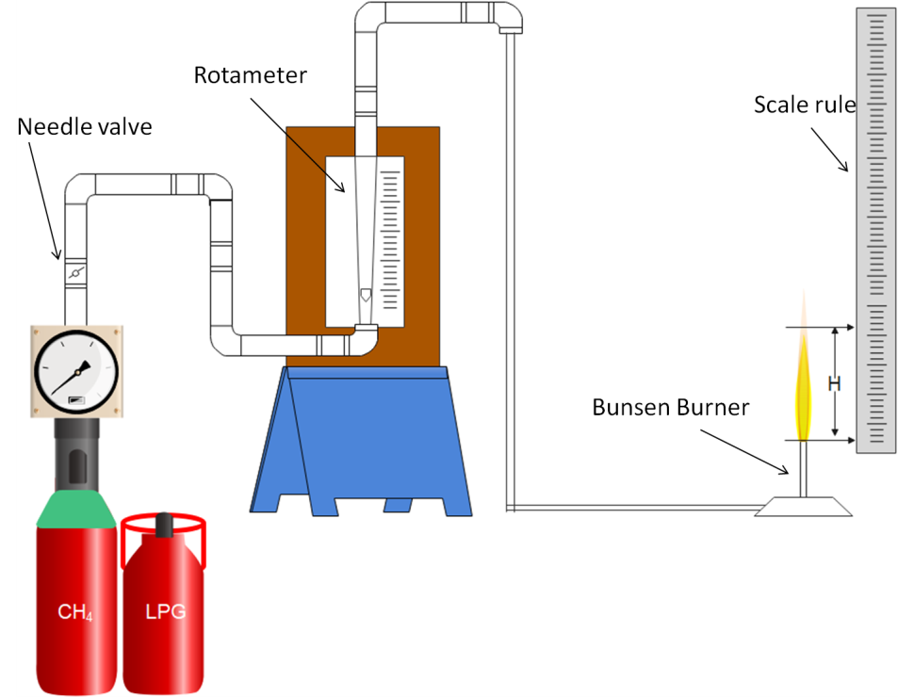

*Figure 1: Schematic of Experimental Setup*

The experimental setup used is show in Fig. 1. It consists of a gaseous fuel (LPG or Methane) Cylinder connected to a Bunsen burner through a Rotameter. The rotameter connected to the cylinder indicates the volumetric flow reading of fuel, during the experiment. A needle valve is also kept in between the gas cylinder and the rotameter to adjust the flow rates.

The gas emanating from the burner is ignited with a pilot flame and the volumetric flow rate reading of the cylinder was recorded from the rotameter, while the corresponding flame height is measured using the scale rule. In this experiment oxygen calibrated rotameter is used, hence the flow rates are corrected for LPG and CH4 by a correction factor.

In order to obtain the correction factor following steps are followed:

Specific gravity (SG): $SG=\frac{Molecular weight of gas}{Molecular weight of O_{2}}$

$SG= \frac{\left(\%A ×Molecular weight of A\right)+ (\%B ×Molecular weight of B)}{Molecular weight of O_{2}}$

Correction factor (CF): $CF= \sqrt{\frac{1}{SG}}$

CF = 0.722 for LPG

CF = 0.84 for CH4

In the present experiment three cases are considered.

Case 1: LPG gas with 10 mm diameter tube

Case 2: CH4 gas with 5 mm diameter tube

Case 3: CH4 gas with 10 mm diameter tube

The diffusion flame heights are measured from the experiment video by noting the height of the flame from the scale adjacent to the burner. The corresponding flow rate readings also need to be recorded and should be corrected for the fuel used.

Case-1 : LPG (10mm diameter)

| Sl. No. | Flow rate (in LPM) | Corrected flow rate (in LPM) | Flame height (H) (in cm) |
| --- | --- | --- | --- |
| 1. | 5 | 3.61 | 70 |
| 2. | 10 | 7.22 | 75 |
| 3. | 15 | 10.83 | 110 |
| 4. | 20 | 14.44 | 120 |
| 5. | 25 | 18.05 | 130 |
| 6. | 30 | 21.66 | 140 |
| 7. | 35 | 25.27 | 150 |

Case-2 : Methane (5mm diameter)

| Sl. No. | Flow rate (in LPM) | Corrected flow rate (in LPM) | Flame height (H) (in cm) |
| --- | --- | --- | --- |
| 1. | 5 | 4.2 | 55 |
| 2. | 10 | 8.4 | 60 |
| 3. | 15 | 13.44 | 75 |
| 4. | 20 | 16.8 | 80 |
| 5. | 25 | 21 | 85 |
| 6. | 30 | 25.2 | 90 |
| 7. | 35 | 29.4 | 95 |
| 8. | 40 | 33.6 | 97.5 |
| 9. | 45 | 37.8 | 100 |
| 10. | 52 | 43.68 | 100 |

Case-3 : Methane (10mm diameter)

| Sl. No. | Flow rate (in LPM) | Corrected flow of LPG (in LPM) | Flame height (H) (in cm) |
| --- | --- | --- | --- |
| 1. | 10 | 8.4 | 65 |
| 2. | 20 | 16.8 | 85 |
| 3. | 30 | 25.2 | 100 |
| 4. | 40 | 33.6 | 120 |
| 5. | 50 | 42 | 140 |

**The measured diffusion flame heights (H) are to be plotted on y-axis along with the corrected mass flow rate of fuel consumed on x-axis.**

**Case-1**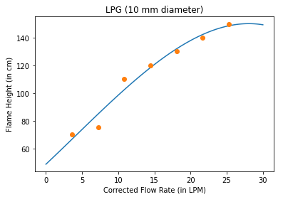

**Case-2**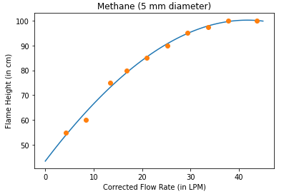

**Case-3**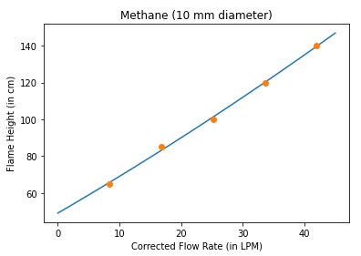

**What are the conclusions you can draw?**

1. For same diameter, and different Fuels:

We see that LPG (Propane - 44.097 g/mole) flow turns turbulent at a lower flow rate than Methane (16.04246 g/mol). This can be seen as the plot for LPG Flame Height starts converging to a constant value earlier than the plot for Methane Flame Height, which is still increasing for the same range of Corrected Flow Rate.

Thus, keeping the flow rate and diameter constant, the mass of the fuel used affects the flame height. Fuels with higher molecular weight turn turbulent faster than fuels with a lower molecular weight.

2. For same Fuel, and different diameter

We see that as we increase the diameter, for the same flow rate, the velocity at which the fuel flows decreases. Thus, the onset of Turbulent flow is delayed. This can be seen as the plot for the Methane flow through 5mm diameter converges to a constant flame height (turns turbulent) earlier than the Methane flow through 10mm diameter at the same Flow rate.

Thus, keeping the flow rate and the fuel constant, the diameter affects the flame height. Larger diameter reduces the fuel flow velocity and thus flow stays laminar for longer, than having a lower diameter which has a higher fuel flow velocity for the same flow rate.